Experiment 1

Aim: To implement and test a Mathematical game for kids based on the Principles of HMI

Theory:

Problem Definition:

The subject of mathematics addresses the fundamental concepts on which knowledge of a number of other subjects is built. In such a scenario, mathematical literacy becomes increasingly important to inculcate and develop at a younger age. The most basic operation for kids to learn includes addition and subtraction.

The innovation in our project lies in the application of animations and technological constructs to the paradigm of teaching mathematics, which is the main focus of this study. We will investigate the principles of design and development of a system that can ‘make math fun for kids’.

Motivation:

1. Creativity & Innovation - develop an application to help kindergarten kids to learn addition and subtraction operations by memorizing the images of most lovable objects. Moreover, thinking outside the box to find creative solutions by memorizing animated images is an innovative way to mathematics.

2. Design Thinking - follow design processes including ideating, prototyping, testing, iterating and giving feedback, all in tandem with core game design principles. A test after a lesson is must to check how much a kid has grasped.

Goals:

A. Critical Thinking & Problem Solving - kids challenge themselves to view math from the perspective of a game designer and determine best approaches to evoke meaningful play.

B. Math Literacy - kids engage meaningfully with math concepts in new ways to build deeper understanding and long memory.

C. Digital Literacy - kids have the opportunity to learn and utilize digital memory which is possible through hilarious videos and gif animations of well known characters.

Outcome:

Our approach consists of two phases for children to learn basic addition and subtraction in the simplest way. The first phase is of learning with the help of animated pictorial memories which is considered to be very productive in case of kindergarten kids. Once learning is done, kids are tested with the help of funny gifs of their favourite characters. This ensures that while getting correct answered they are lured to practice more. On the other hand, wrong answers also doesn’t discourage them as the game is never over as it usually occurs in other applications.

. Here we first present a comparative study of these existing “ games for kids”:

|  |  |  |  |
| --- | --- | --- | --- |
| **Name** | ABCYA marble | Rooftop Running | Sudoku |
| **Complexity** | High | Medium | High |
| **Concepts Addressed** | High | Medium | High |
| **Game Length** | Medium | High | High |
| **Popularity** | High | Medium | Medium |

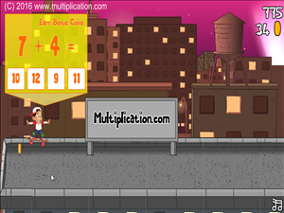 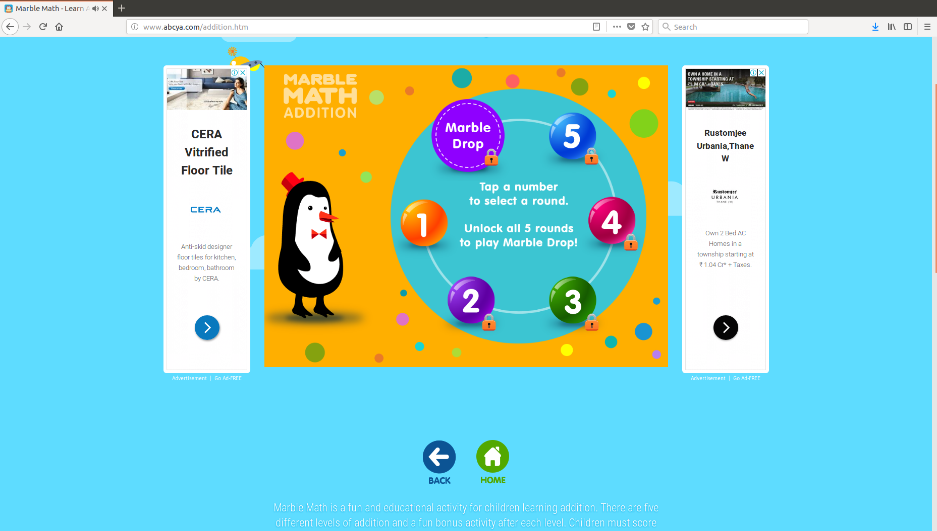

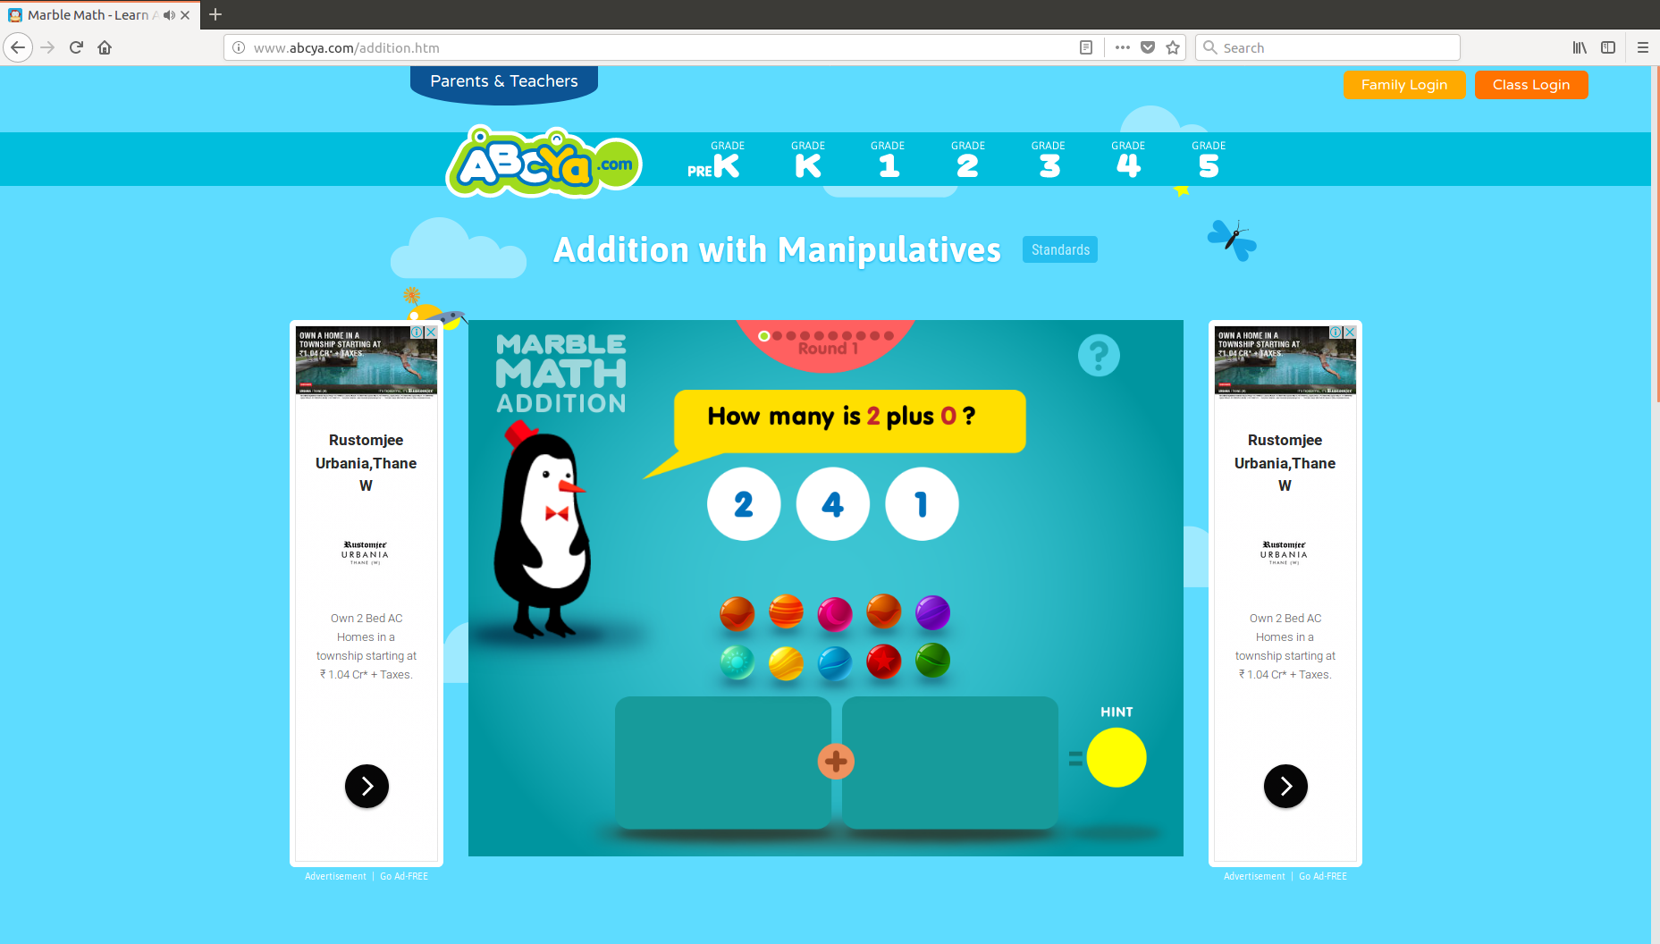 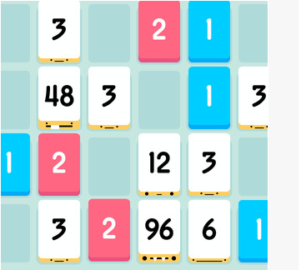

Case Study of Existing Games: Sudoku, abcya marble game, rooftop running game

Analysis:

A cursory analysis of this Matrix can tell us a lot about the nature of the game and the expectations of the public from such a game.

The complexity of the games ranges from medium to high, which makes it difficult for children to pick up on it easily.

The popularity is not necessarily driven by complexity of coverage of concepts.

Game length being high does impact its popularity.

Interest among users is often piqued by uniqueness of the design and simplicity of games.

We address these flaws in our application:

It is designed for low-complexity, making it accessible to children of all ages.

It implements a variety of concepts compared to the games above like pictorial memory, animations involving funny gifs which makes learning fun.

Within the scope of learning it is relatively popular given the clean interface and design.

The interest is piqued due to the inclusion of well known objects and characters, especially while going wrong in the testing phase kids end up smiling instead of getting discouraged. Thus, luring them to carry on learning with enjoyment.

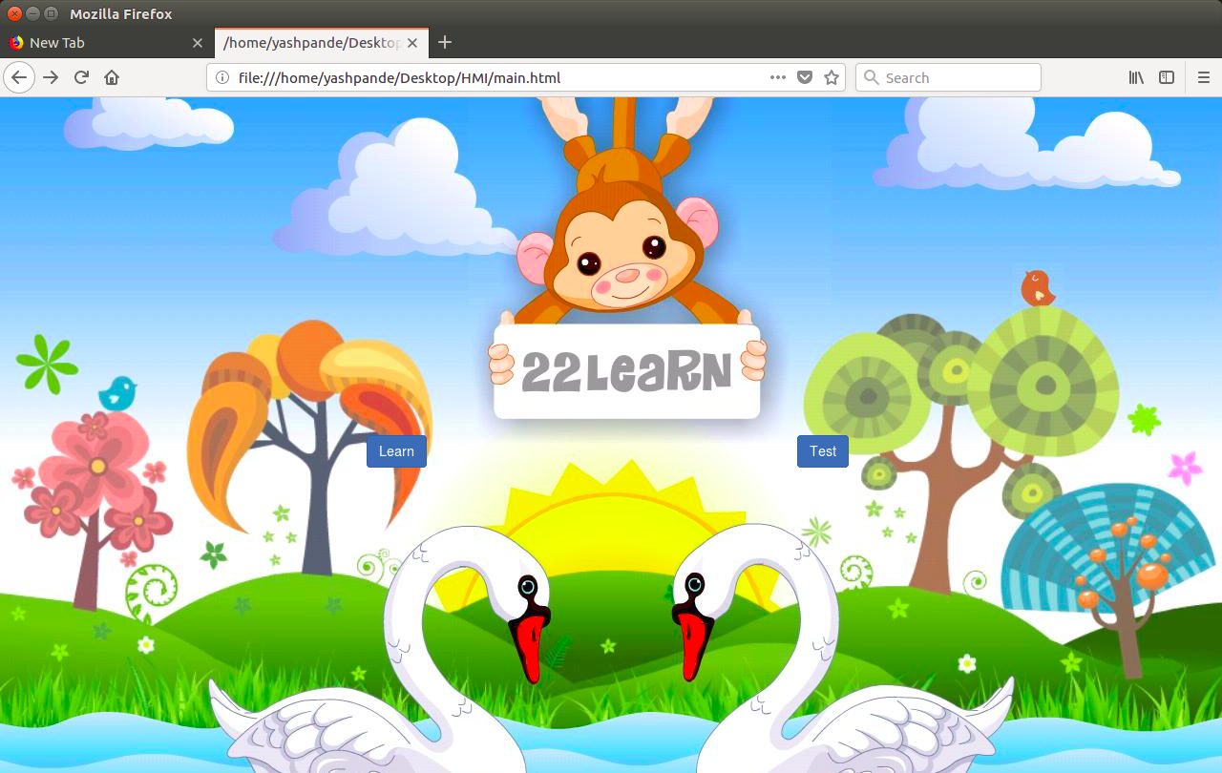

Figure 1: Sample home introductory page to attract kids to start learning

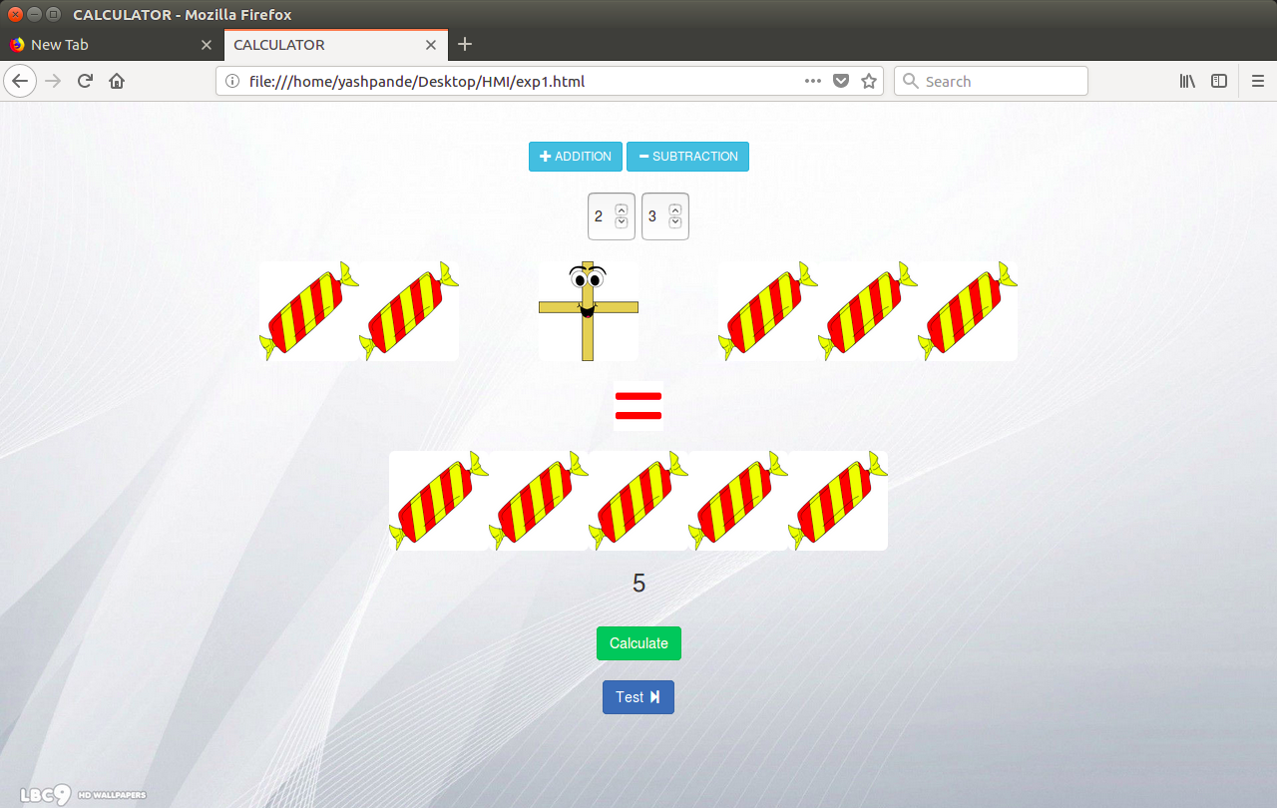

Figure 2: Sample design instance for learning basic addition

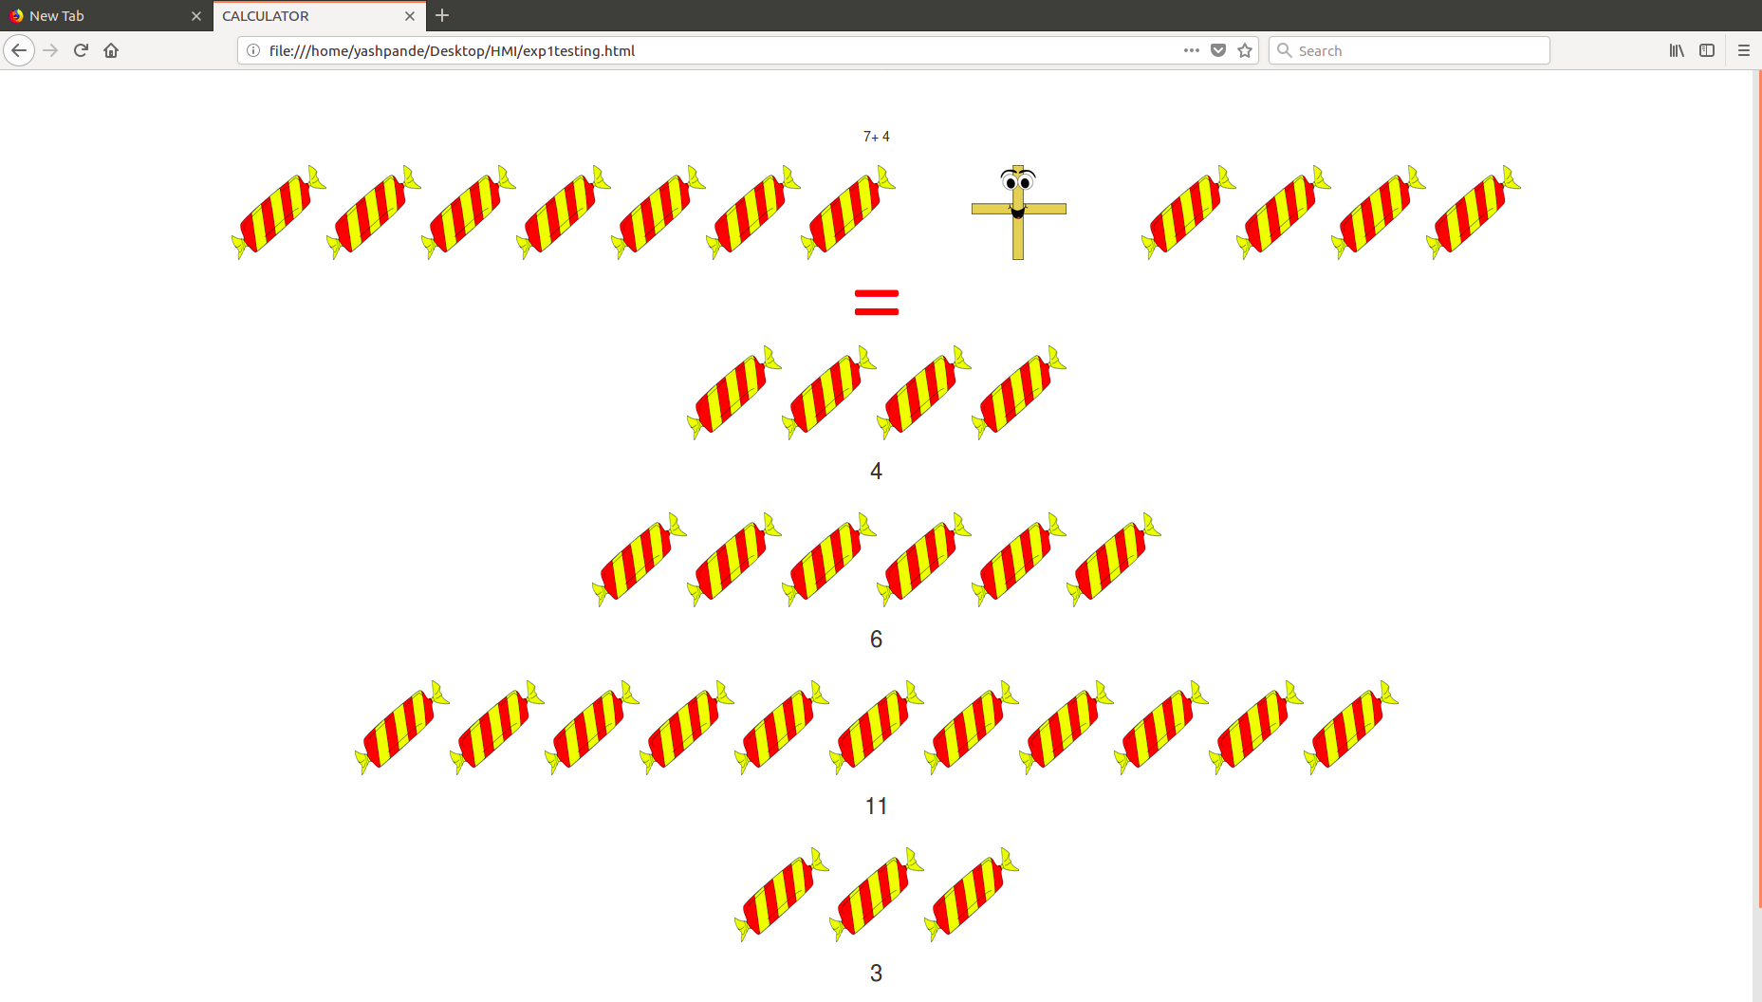

Figure 3: Sample design instance for testing how much addition did a kid learn

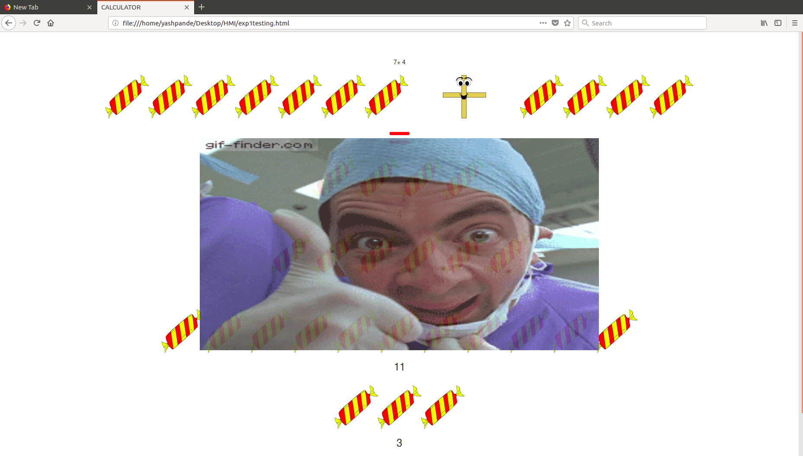

Figure 4: Sample animation gif to encourage a kid on getting correct answer

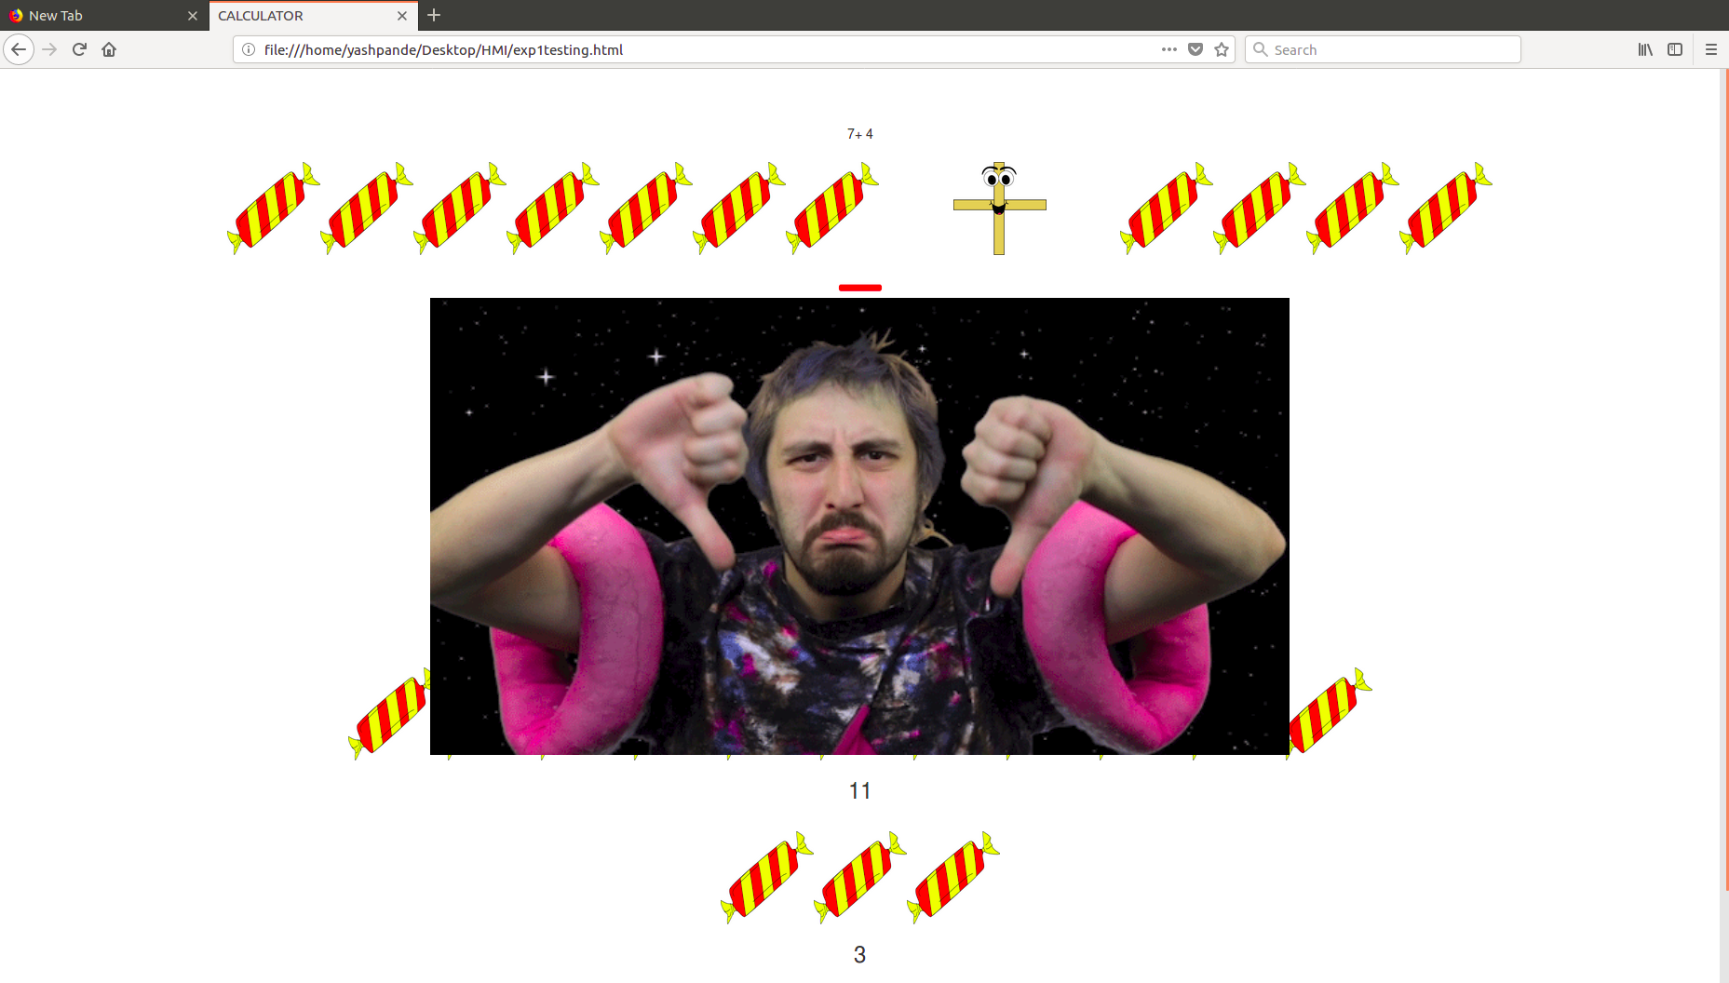

Figure 5: Sample animation gif to encourage a kid on getting correct answer next time

Conclusion:

Thus we have studied, improved, and implemented an educational tool that can be used by children to gain familiarity with the fundamentals of mathematics.